Solar Car Readings

Reading 2.1–The Chassis
The chassis is the frame of your car. All the other parts get attach either directly or indirectly to the chassis. The bearings get glued directly to the bottom of the chassis. The axles spin inside of the bearings, so they attach indirectly to the chassis. You will also attach solar panel supports, the motor and a battery pack directly to the top of the chassis.
A longer, wider chassis is easier to mount axles and get to roll straight but is heavier. You can cut your chassis shorter to reduce the weight, but it makes it harder to keep it moving straight.
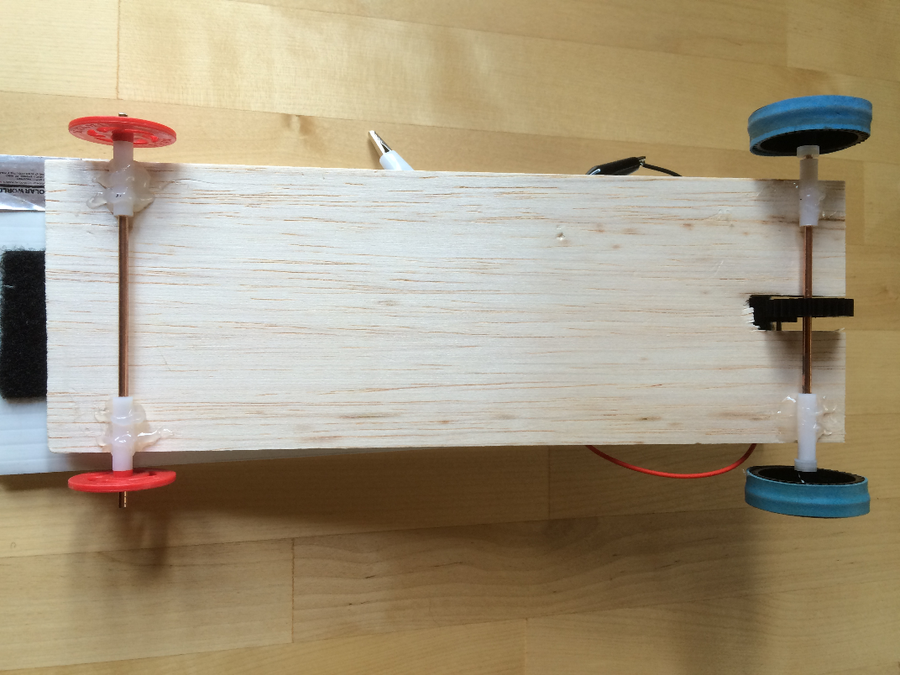
Chassis
Bearings
Axles
Drive Gear

Reading 3.2–The Bearings, Axles and Wheels
The bearings are four small plastic tubes. Your axles spin inside these tubes and allow your car to roll. The bearings are the most important factor in determining the success of your solar car. Poor installation of your bearings can lead to a car that turns too much and/or a lot of friction! Take your time and do this well!
The tubing(bearing) must extend a little beyond the side of the chassis so that the wheels or gear will not make contact with the chassis. This will cause a ton of FRICTION.
Use the T-square to mount the bearings to the chassis. This tool creates a perfect 90-degree angle and mounts your bearings on perfectly (when used
Notice that the bearing extends beyond the chassis.
The finger holds the axle in place while the glue dries. Don’t move your finger for at least 60 seconds!
correctly) and will make your car runs very straight. If your car
does not run straight, it will run along
the side of the track creating a lot of
FRICTION.

The Axles
Axles are metal bars that spin inside of the
bearings and attach your wheels
and gears to the chassis. Axles
must be straight! A bent axle
creates a lot of FRICTION.
You have two material options
for your axles:

- Steel: Steel axles are heavy, but they are hard to bend. Everyone starts with steel axles because they are much easier to work with. Once you get your car done you can then switch to aluminum if you want.
- Aluminum: Light, but they bend VERY easily. It is more important for the car to have a straight axle then a little weight loss. However, the lighter your car, the faster it will go. You can only get aluminum axles after you have built your car and you are trying to improve it for the final race.
To test an axle and see if it is straight, you roll the axle on the desk. It should easily roll 3-4 inches without wobbling.
NEVER get glue on the axles! It is easy to do and will slow your car down a lot because of FRICTION.

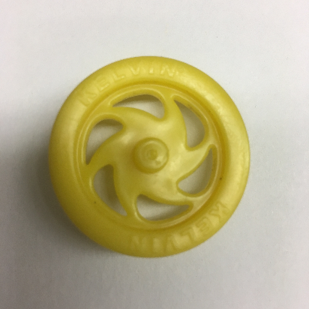
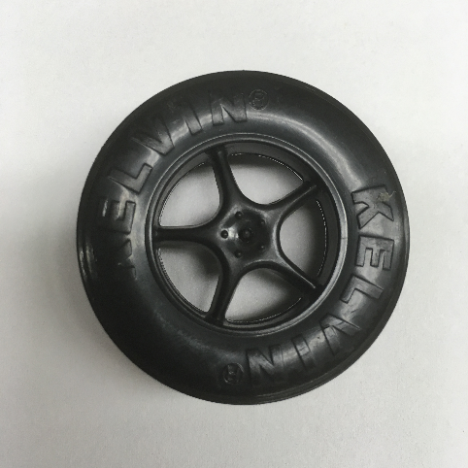
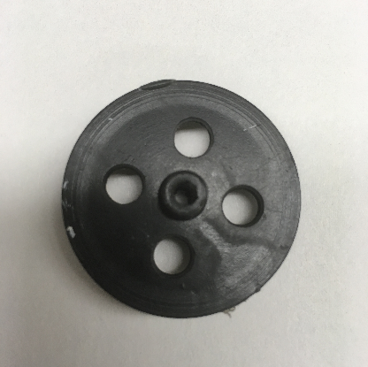
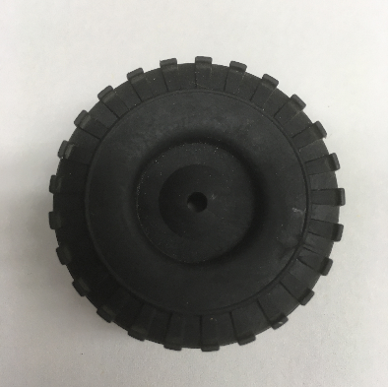

The Wheels

Wheel diameter matters. A larger wheel will be harder for the motor to turn, but will have a higher top speed.
Sometimes FRICTION is good. It is essential to have friction between the wheel and the ground or your car wheels will only spin and not move. You also need friction between the wheels and the axles. If there is not enough friction between the wheels and the axles, the wheels will fall off!

The roll down test

What do I do if my car is turning?
- My car keeps on curving in one direction.
  - Check the wheels to see if they are tight up against the bearings or not. Too much friction will cause the car to curve. If they are too loose, put some washers in between the wheel and the bearing.
  - Check that your bearings are on straight. If not, remove them, and use a T-Square to place them accurately. Be careful, this is the most important part of keeping your car going straight.
  - Make sure that any wires, or other things glued on the chassis are not dragging on the ground or are rubbing against the wheels.
  - Try adding rubber grips to your wheels for more traction.
  - Make sure that the weight of everything on the chassis is evenly distributed.

Reading 5.1: The Gears
Gears are like wheels with teeth on them. They transfer the energy in the motor to the wheels. There are two different types of gears. The pinion gear and the drive gear. The pinion gear attaches to the motor and is smaller with fewer teeth. The drive gear is attached to the axle and is larger with more teeth.
You have to choose what gears you want to use. The gear ratio makes a big difference in your cars performance. You calculate the gear ratio by dividing the drive gear teeth by the pinion gear teeth.
Most speed cars will use the medium size gear or the gear that is built into the black wheel. You will need to decide which is better. The smaller your gear ratio, the higher your top speed. The downside is that you lose torque.
The gear needs to be tight on the axle! If it is easy to get the gear on, it will likely spin on the axle and you will lose power.
Positioning of the motor is very important. If the gears are too close there will be a lot of extra friction. If they are too far apart they will make a very loud noise and your car will go nowhere.
Never get glue, paint or anything else on the gear teeth. This adds more friction.
You can change the tension between the gears by moving the motor slightly. Start with less glue on the motor and a weak battery.
To calculate the gear ratio, you divide the number of teeth on the drive gear by the number of teeth on the pinion gear.

Friction Alert!
There is always a balance to be had with friction and the gears. If the gears are too close, there is too much friction. Too far apart and there is not enough to make the wheels move. Also, be careful that wires are not rubbing against any wheels or gears!

Torque vs. Top Speed:
Torque is a measurement of FORCE.
You have a set amount of force from your motor. If
you concentrate that force over a short distance, you
have more torque. More torque means a faster start
off the line, but you will have a lower top speed.
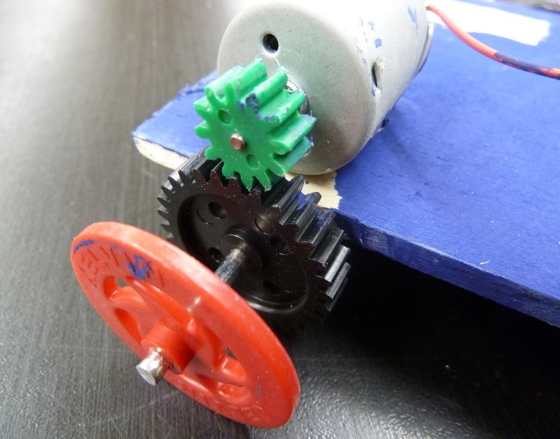
Pinion Gear must match up with the drive gear
Pinion Gear
Drive Gear

Reading 6.1 – What do I need to finish my car?

MOTOR
The motor converts the electrical energy of the battery and the solar panel and converts it into mechanical energy that can turn the gear.
Positioning of the motor is very important. If the gears are too close there will be a lot of extra FRICTION. If they are too far apart they will make a very loud noise and your car will go nowhere.
You can change the distance between the gears by moving the motor slightly. Start with less glue on the motor and a weak battery.

BATTERY
You need to create space for a battery holder and an on/off switch. It must be easily accessible and close to motor.
We will use the battery pack for most of our trials.
You will start with a single battery pack to keep the speed down on your car. We will use a double battery pack when we have the tracks set up.

SOLAR PANEL SUPPORTS
Solar panels are your power source. The more energy they produce the faster your car will go.
Theoretically, you want to have your solar panel pointing directly towards the sun to get the most energy from the sun. In Oregon, that is nearly a 45-degree angle!

Solar Panel Support

